**Python HARD Challenges**

**1: Maximize It:**

from itertools import product  
K, M = map(int, input().split())  
N = (list(map(int, input().split()))[1:] for _ in range(K))  
max_lst = []  
for item in product(*N):  
 S = 0  
 for val in item:  
 S += val**2  
 S_max = S % M  
 max_lst.append(S_max)  
print(max(max_lst))

**2: Validating Postal Codes:**

regex_integer_in_range = r'^[1-9][\d]{5}$'  
regex_alternating_repetitive_digit_pair = r'(\d)(?=\d\1)'  
  
import re  
P = input()  
  
print(bool(re.match(regex_integer_in_range, P))  
and len(re.findall(regex_alternating_repetitive_digit_pair, P)) < 2)

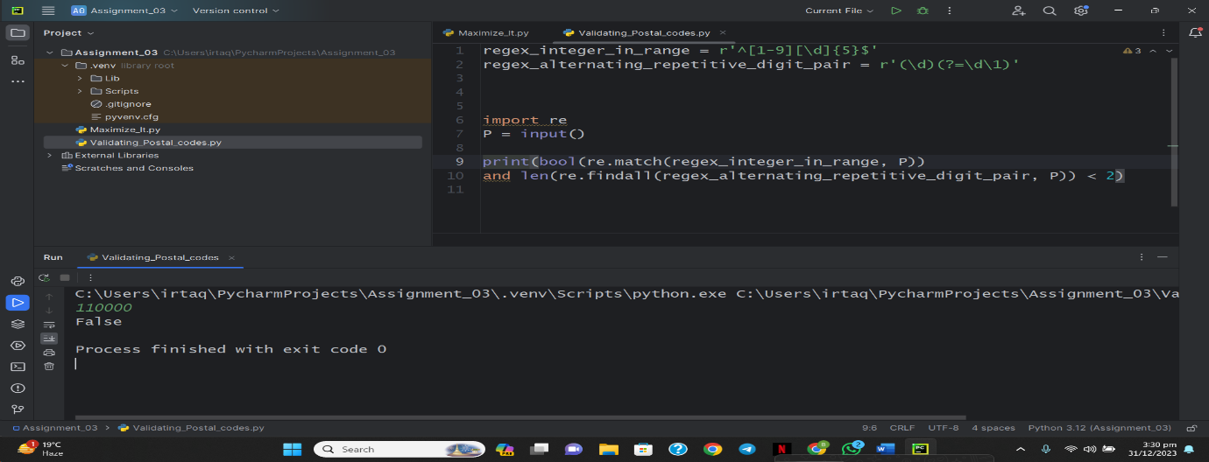

**3: Matrix Script:**

import math  
import os  
import random  
import re  
import sys  
  
first_multiple_input = input().rstrip().split()  
  
n = int(first_multiple_input[0])  
m = int(first_multiple_input[1])  
  
matrix = []  
  
for _ in range(n):  
 matrix_item = input()  
 matrix.append(matrix_item)  
  
# start  
matrix = list(zip(*matrix))  
  
sample = str()  
  
for words in matrix:  
 for char in words:  
 sample += char  
  
print(re.sub(r'(?<=\w)([^\w\d]+)(?=\w)', ' ', sample))

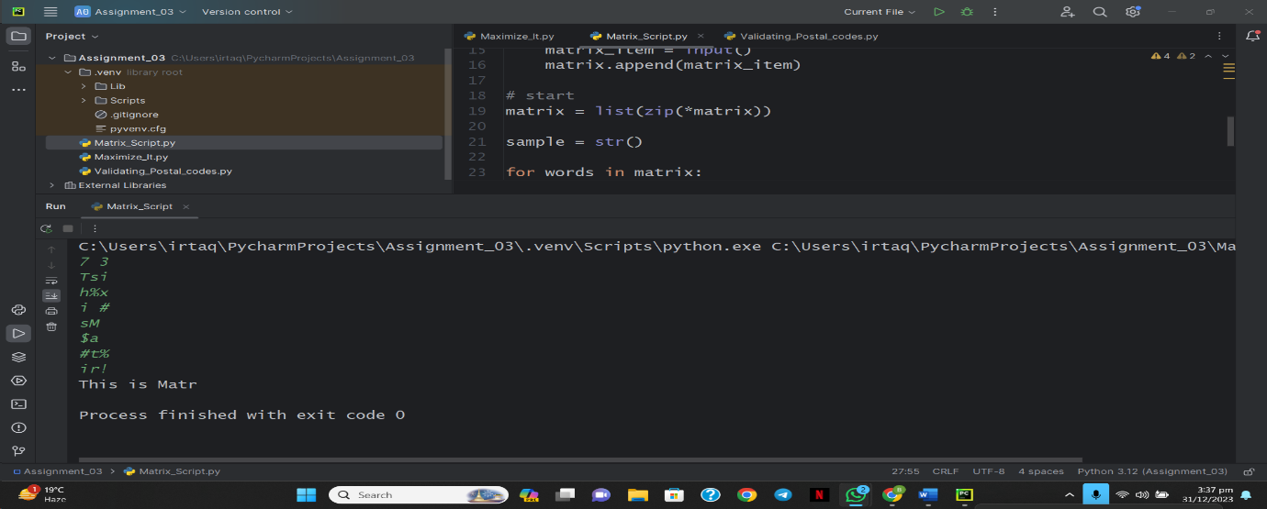

**Python Medium Challenges**

**1: Write a Function**

def is_leap(year):

    leap = False

    if (year % 400 == 0) and (year % 100 == 0):

        leap = True

    elif (year % 4 ==0) and (year % 100 != 0):

        leap = True

    else:

        pass

    return leap

year = int(input())

print(is_leap(year))

**2: The Minion Game**

def minion_game(string):

    s=len(string)

    vowel = 0

    consonant = 0

    for i in range(s):

        if string[i] in 'AEIOU':

            vowel+=(s-i)

        else:

            consonant+=(s-i)

    if vowel < consonant:

        print('Stuart ' + str(consonant))

    elif vowel > consonant:

        print('Kevin ' + str(vowel))

    else:

        print('Draw')

if __name__ == '__main__':

    s = input()

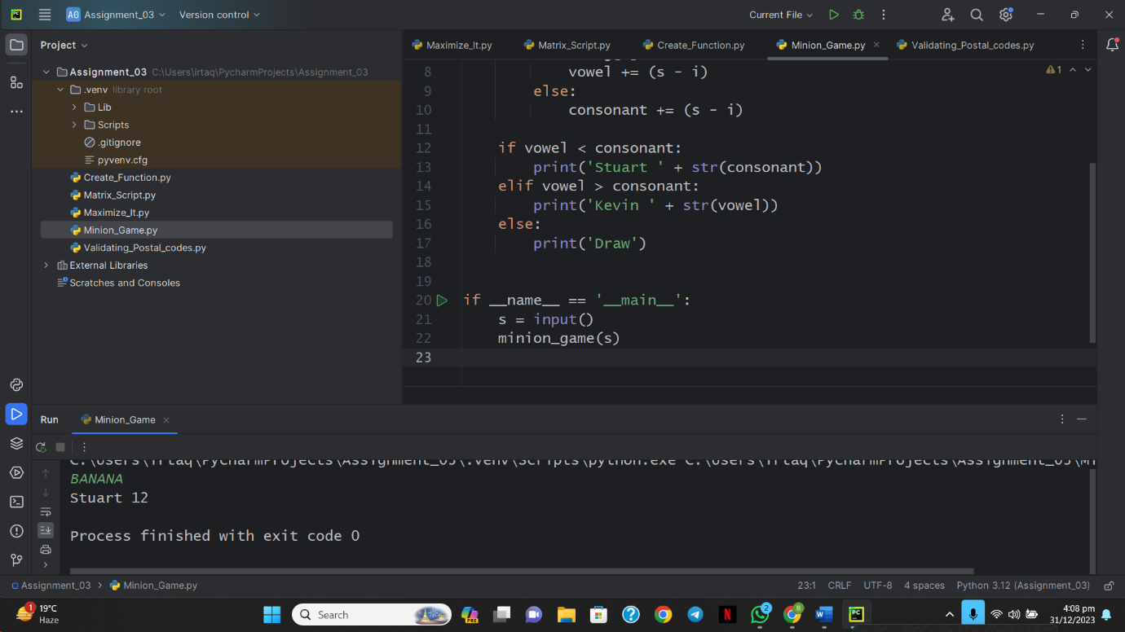    minion_game(s)

**3: Merge the Tools**

def merge_the_tools(string, k):

    temp = []

    len_temp = 0

    for item in string:

        len_temp += 1

        if item not in temp:

            temp.append(item)

        if len_temp == k:

            print(''.join(temp))

            temp = []

            len_temp = 0

if __name__ == '__main__':

    string, k = input(), int(input())

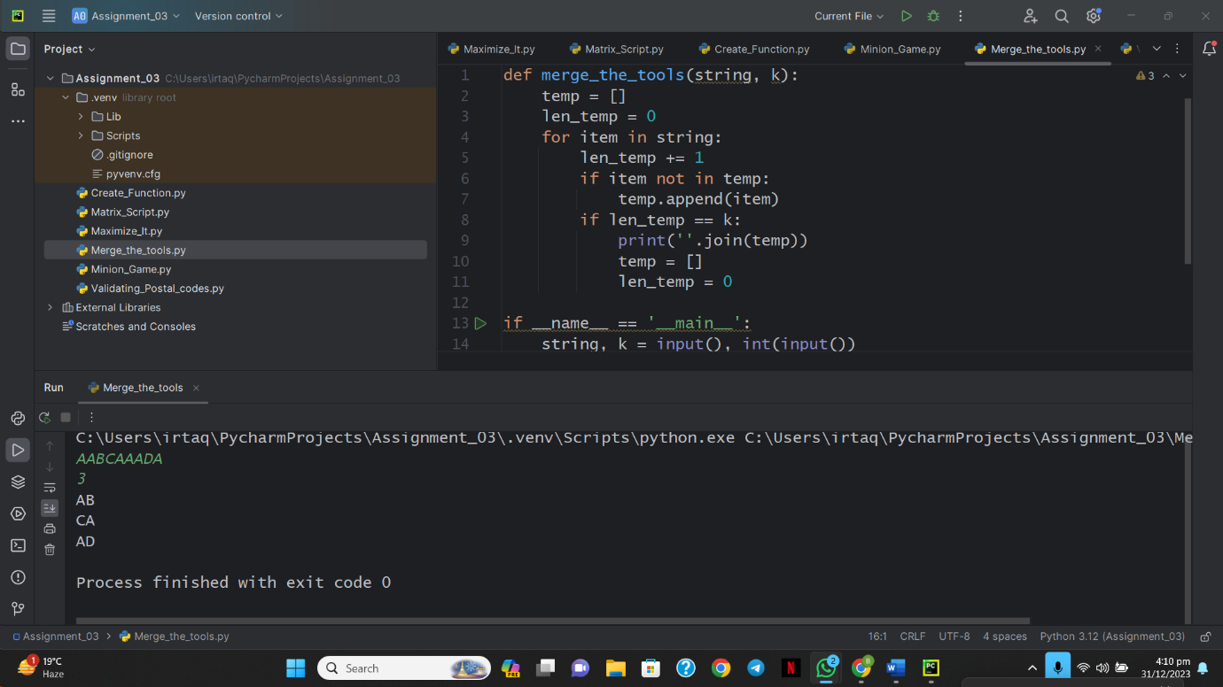    merge_the_tools(string, k)

**4: Time Delta**

import math

import os

import random

import re

import sys

from datetime import datetime

def time_delta(t1, t2):

    t1 = datetime.strptime(t1, '%a %d %b %Y %H:%M:%S %z')

    t2 = datetime.strptime(t2, '%a %d %b %Y %H:%M:%S %z')

    return str(int(abs((t1-t2).total_seconds())))

if __name__ == '__main__':

    fptr = open(os.environ['OUTPUT_PATH'], 'w')

    t = int(input())

    for t_itr in range(t):

        t1 = input()

        t2 = input()

        delta = time_delta(t1, t2)

        fptr.write(delta + '\n')

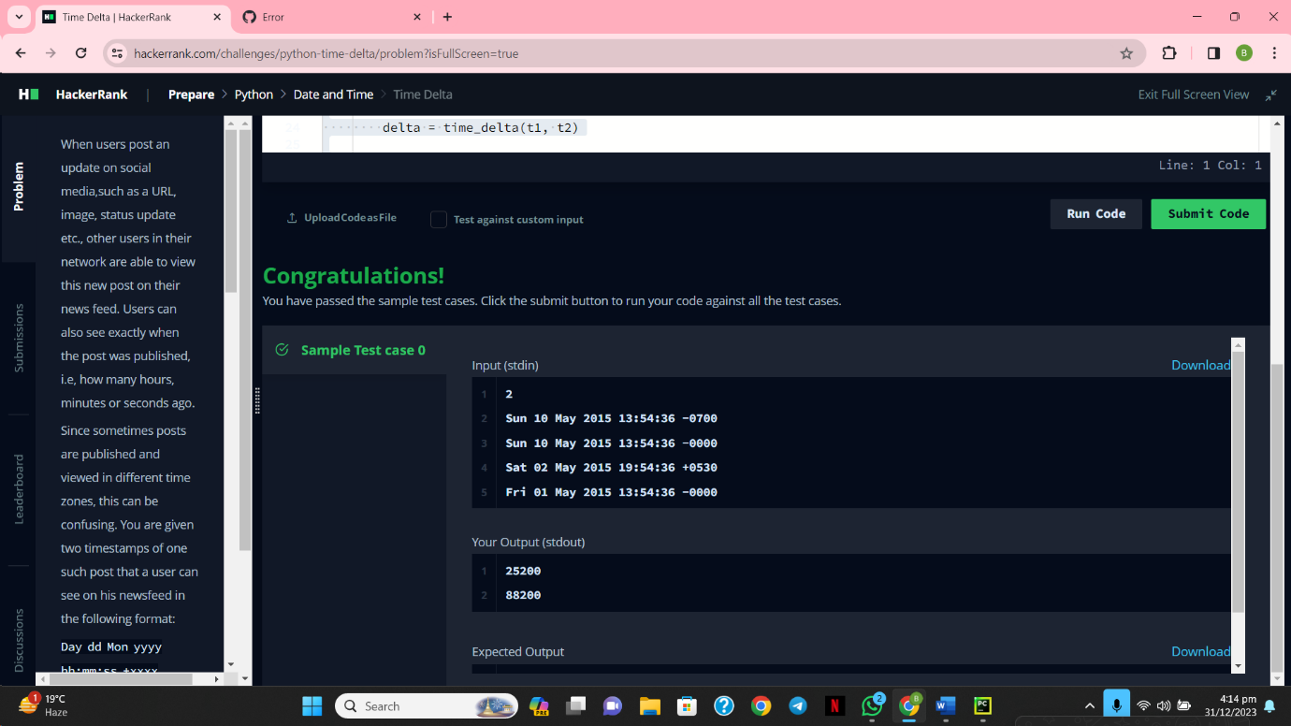    fptr.close()

**5: Find Angle MBC**

import math

ab=int(input())

bc=int(input())

ca=math.hypot(ab, bc)

mc=ca/2

bca=math.asin(1*ab/ca)

bm=math.sqrt((bc**2+mc**2)-(2*bc*mc*math.cos(bca)))

mbc=math.asin(math.sin(bca)*mc/bm)

print(int(round(math.degrees(mbc),0)) ,'\u00B0', sep='')

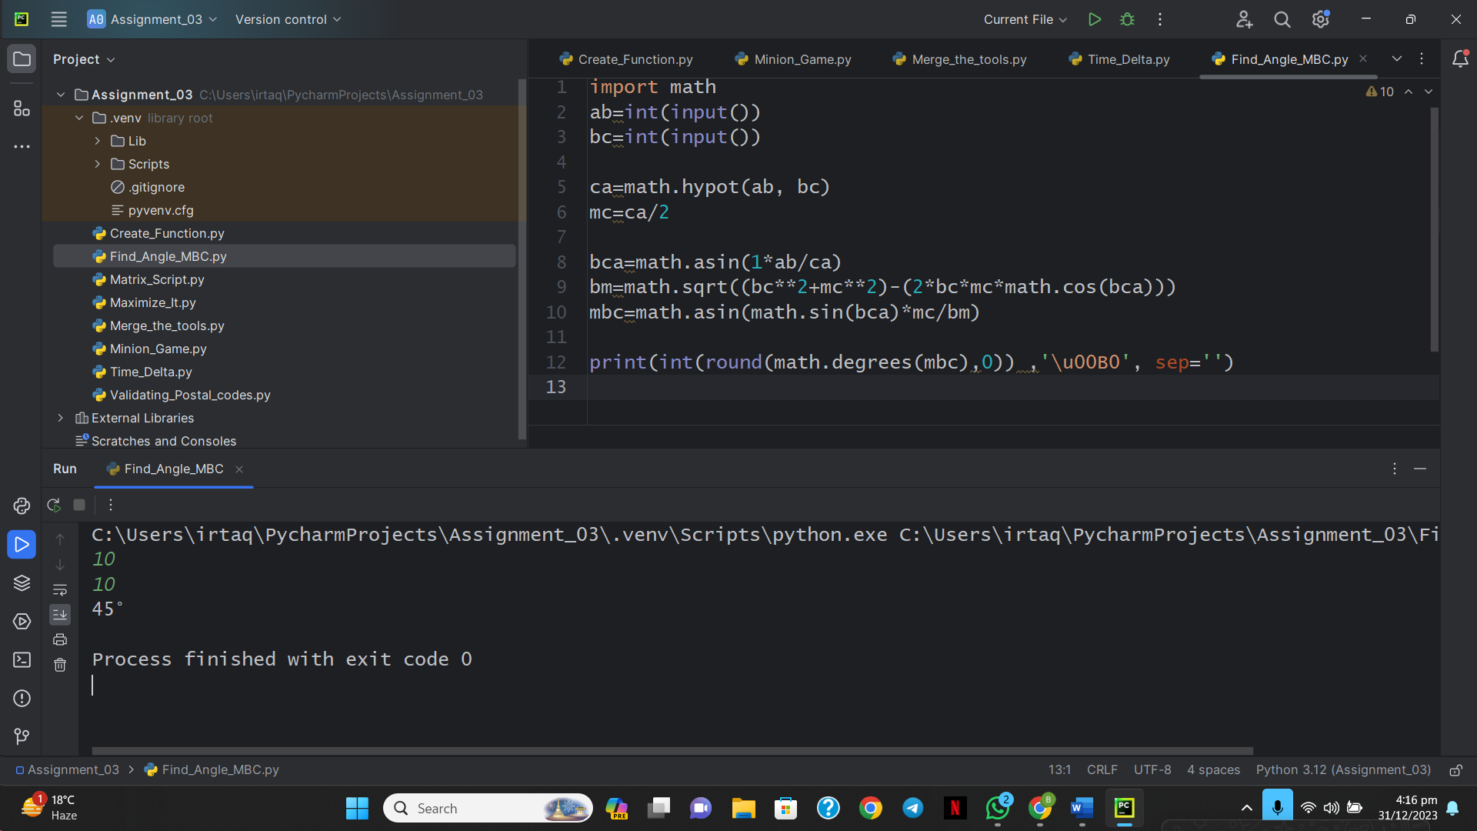

**6: No Idea**

if __name__ == "__main__":

    happiness = 0

    n, m = map(int, input().strip().split(' '))

    elements_arr = list(map(int, input().strip().split(' ')))

    A = set(map(int, input().strip().split(' ')))

    B = set(map(int, input().strip().split(' ')))

    for i in elements_arr:

        if i in A:

            happiness += 1

        elif i in B:

            happiness -= 1

    print(happiness)

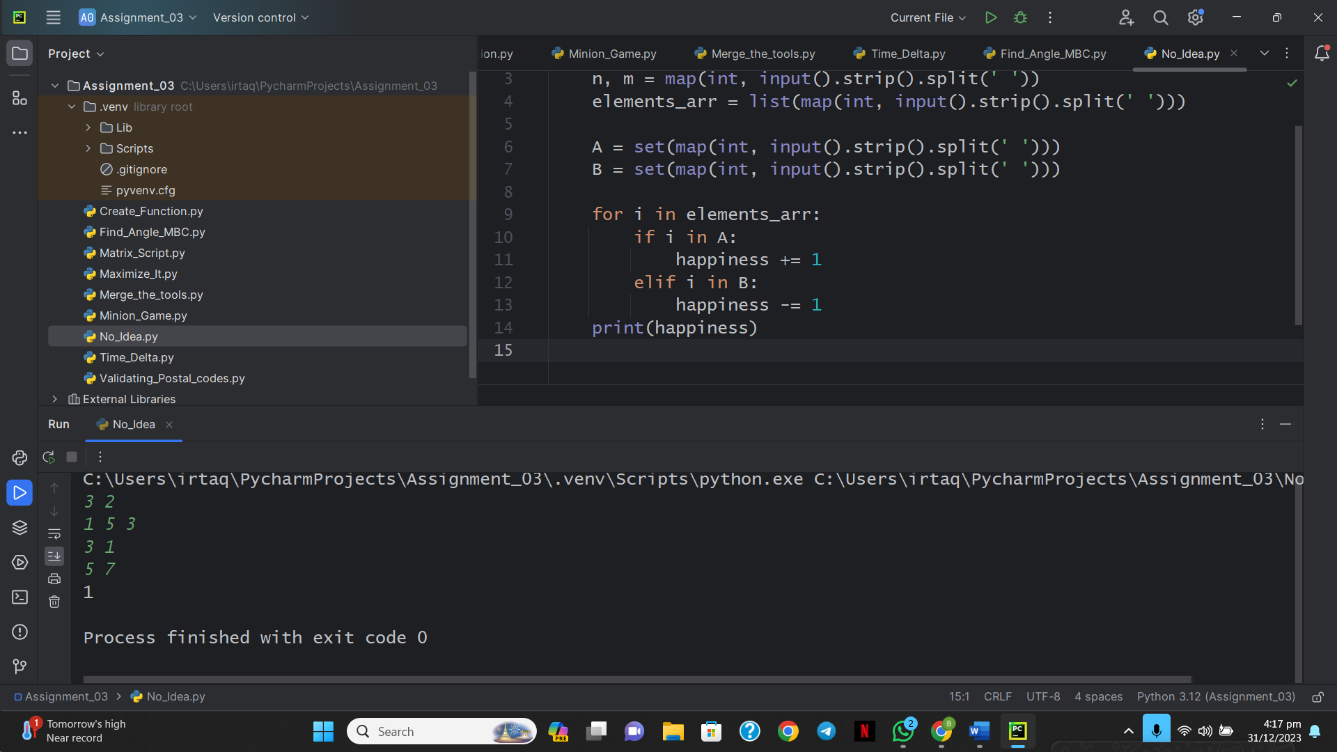

**7: Word Order**

from collections import Counter

n = int(input())

l1 = [input().strip() for _ in range(n)]

res = Counter(l1)

print(len(res))

print(*res.values())

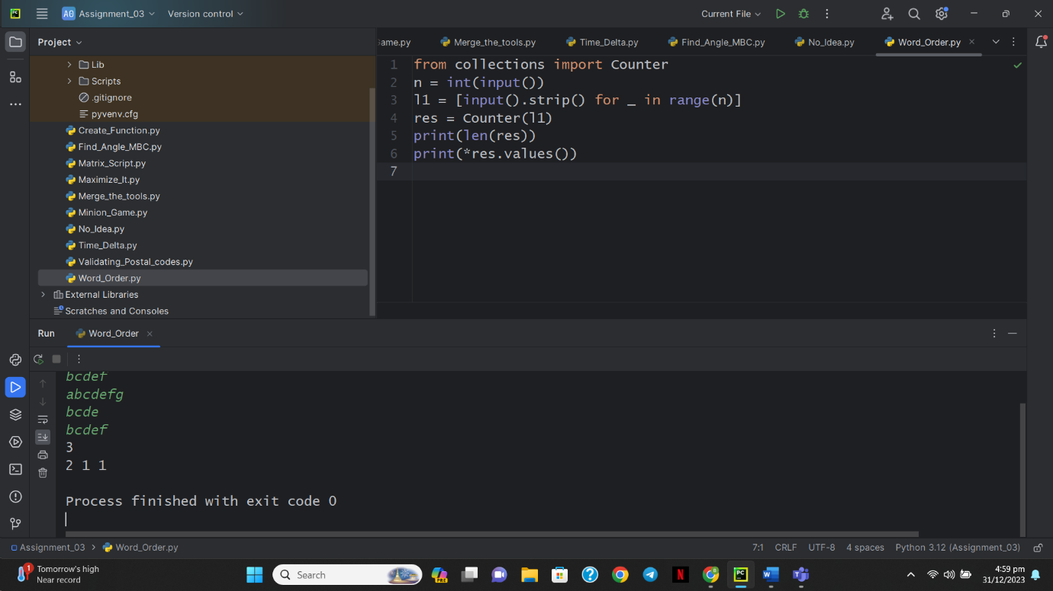

**8: Compress the String**

from itertools import *

io = input()

for i, j in groupby(map(int,list(io))):

    print(tuple([len(list(j)), i]), end=" ")

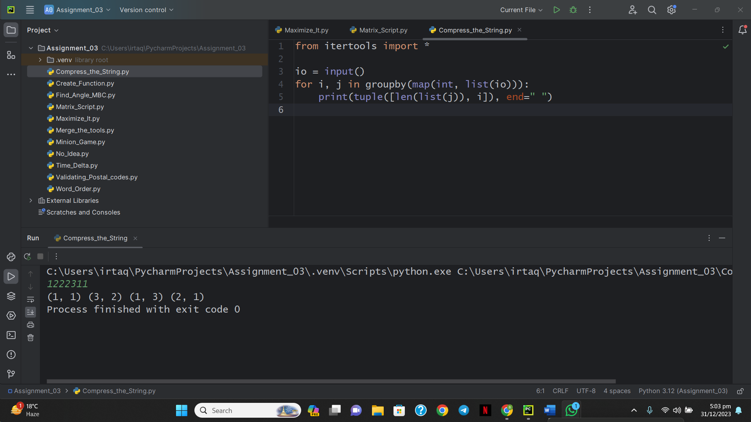

**9: Company Logo**

import math

import os

import random

import re

import sys

from collections import Counter

if __name__ == '__main__':

    s = input()

    s = sorted(s)

    FREQUENCY = Counter(list(s))

    for k, v in FREQUENCY.most_common(3):

        print(k, v)

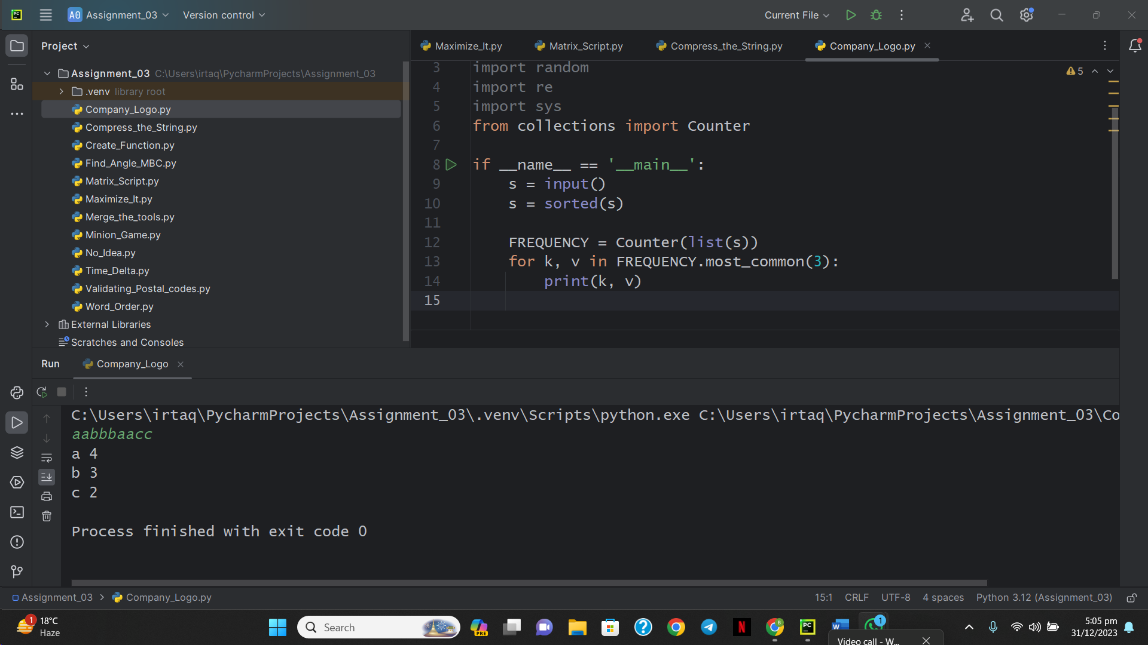

**10: Piling Up**

ANS = []

T = int(input())

for _ in range(T):

    n = int(input())

    sl = list(map(int, input().split()))

    for _ in range(n-1):

        if sl[0] >= sl[len(sl)-1]:

            a = sl[0]

            sl.pop(0)

        elif sl[0] < sl[len(sl)-1]:

            a = sl[len(sl)-1]

            sl.pop(len(sl)-1)

        else:

            pass

        if len(sl) == 1:

            ANS.append("Yes")

        if ((sl[0] > a) or (sl[len(sl)-1] > a)):

            ANS.append("No")

            break

print("\n".join(ANS))

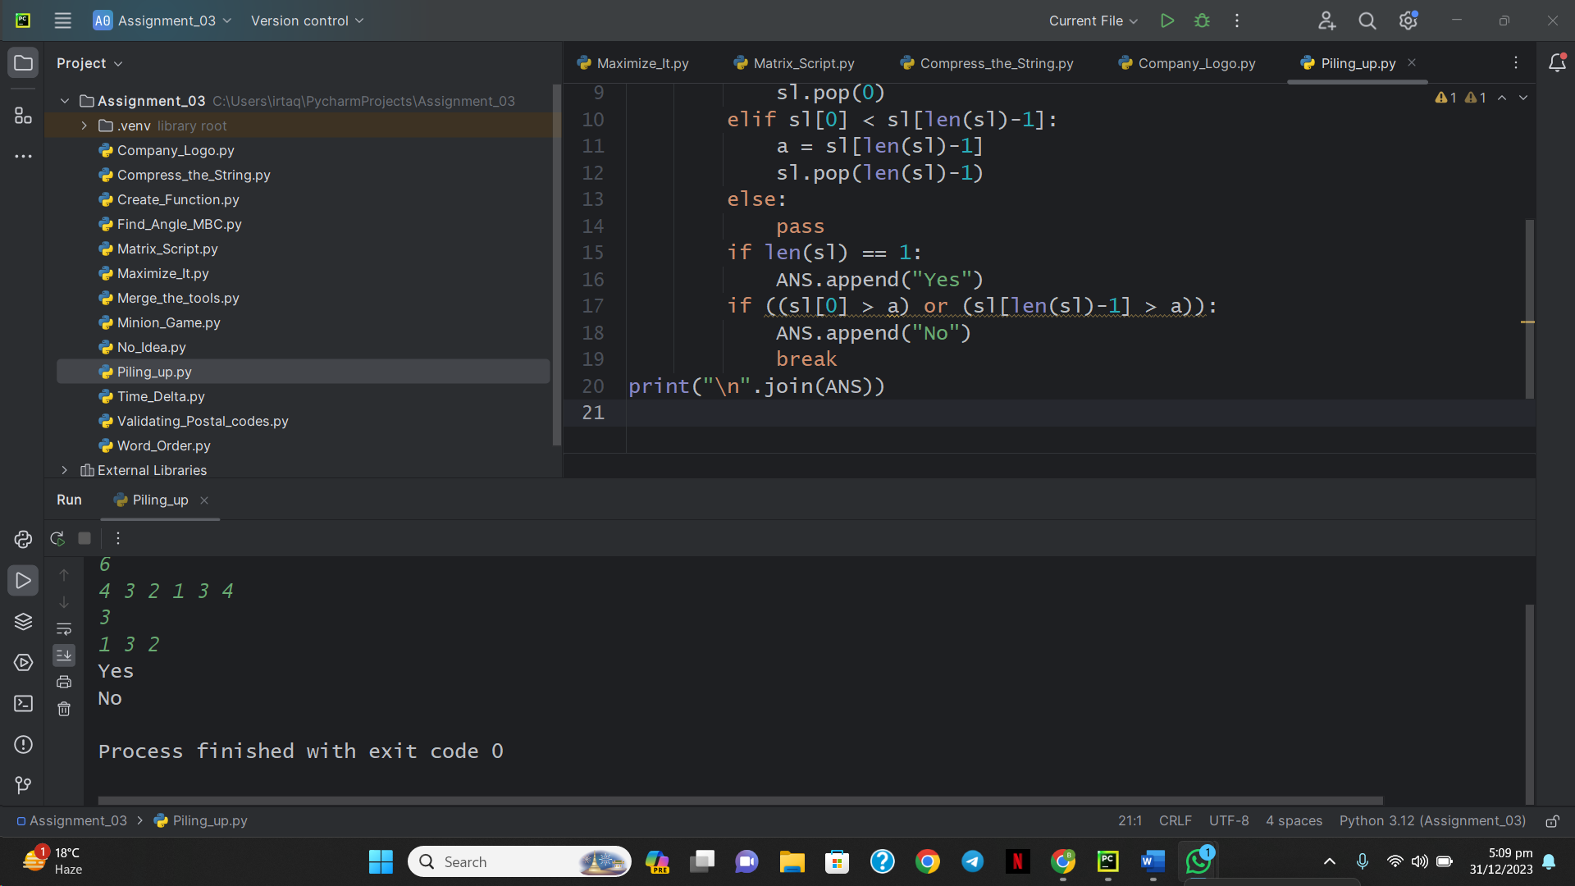

**11: Triangle Quest 2**

for i in range(1, int(input())+1):

    print(((10**i)//9)**2)

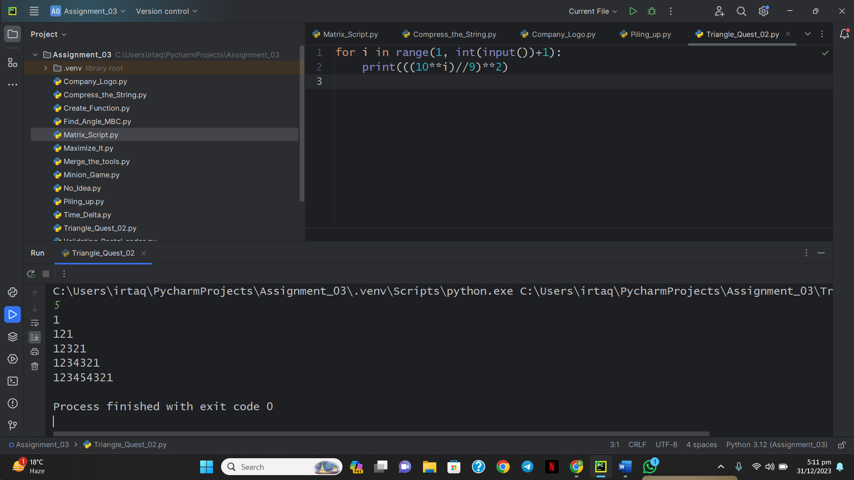

**12: Iterables and Iterators**

from itertools import combinations

N = int(input())

L = input().split()

K = int(input())

C = list(combinations(L, K))

F = filter(lambda c: 'a' in c, C)

print('{0:.3}'.format(len(list(F))/len(C)))

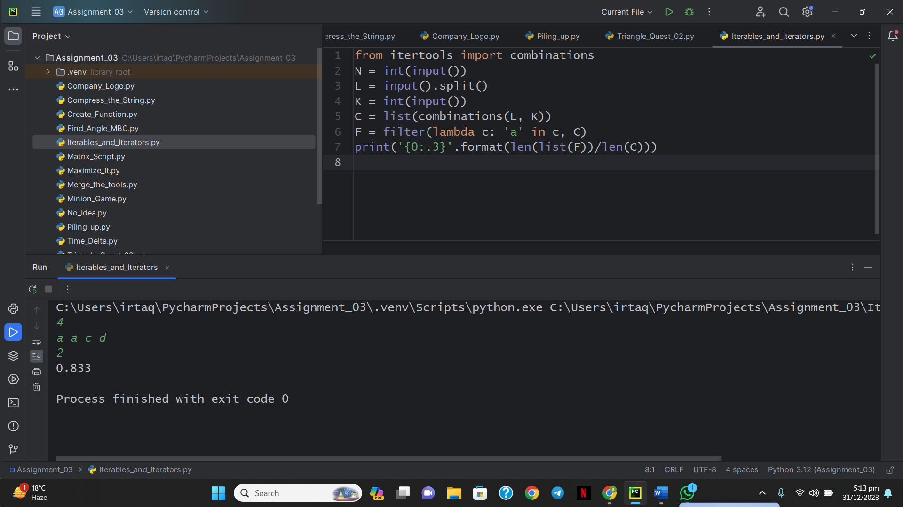

**13: Triangle Quest**

for i in range(1, int(input())):

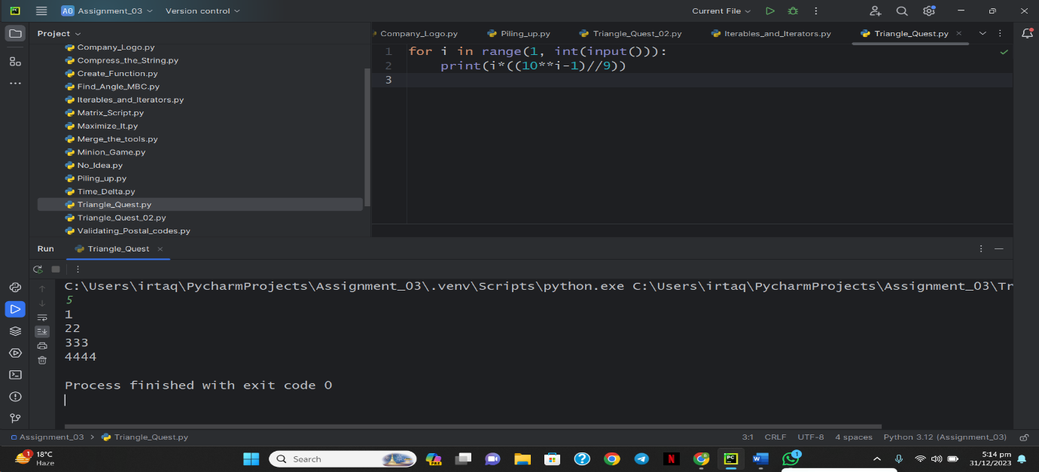    print(i*((10**i-1)//9))

**14: Classes: Dealing with Complex Numbers**

import math

class Complex(object):

    def __init__(self, real, imaginary):

        self.real = real

        self.imaginary = imaginary

    def __add__(self, no):

        return Complex(self.real + no.real,self.imaginary + no.imaginary)

    def __sub__(self, no):

        return Complex(self.real - no.real,self.imaginary - no.imaginary)

    def __mul__(self, no):

        prod = complex(self.real , self.imaginary)*complex(no.real , no.imaginary)

        return Complex(prod.real , prod.imag)

    def __truediv__(self, no):

        div = complex(self.real , self.imaginary)/complex(no.real , no.imaginary)

        return Complex(div.real , div.imag)

    def mod(self):

        m = math.sqrt(self.real**2 + self.imaginary**2)

        return Complex(m,0)

    def __str__(self):

        if self.imaginary == 0:

            result = "%.2f+0.00i" % (self.real)

        elif self.real == 0:

            if self.imaginary >= 0:

                result = "0.00+%.2fi" % (self.imaginary)

            else:

                result = "0.00-%.2fi" % (abs(self.imaginary))

        elif self.imaginary > 0:

            result = "%.2f+%.2fi" % (self.real, self.imaginary)

        else:

            result = "%.2f-%.2fi" % (self.real, abs(self.imaginary))

        return result

if __name__ == '__main__':

    c = map(float, input().split())

    d = map(float, input().split())

    x = Complex(*c)

    y = Complex(*d)

    print(*map(str, [x+y, x-y, x*y, x/y, x.mod(), y.mod()]), sep='\n')

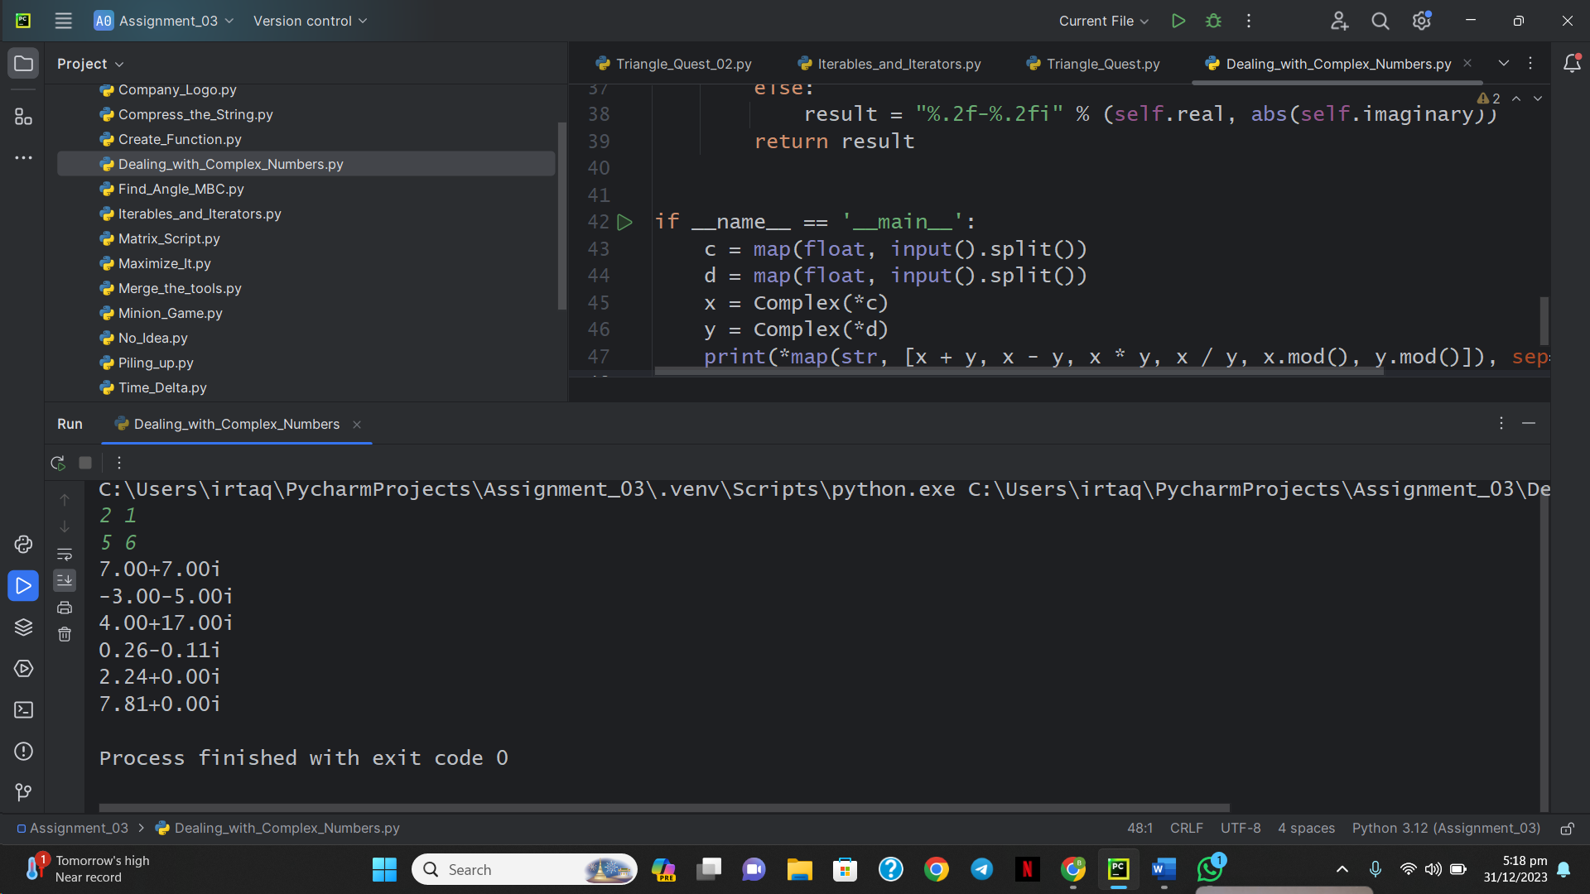

**15: Athlete Sort**

N, M = map(int, input().split())

rows = [input() for _ in range(N)]

K = int(input())

for row in sorted(rows, key=lambda row: int(row.split()[K])):

    print(row)

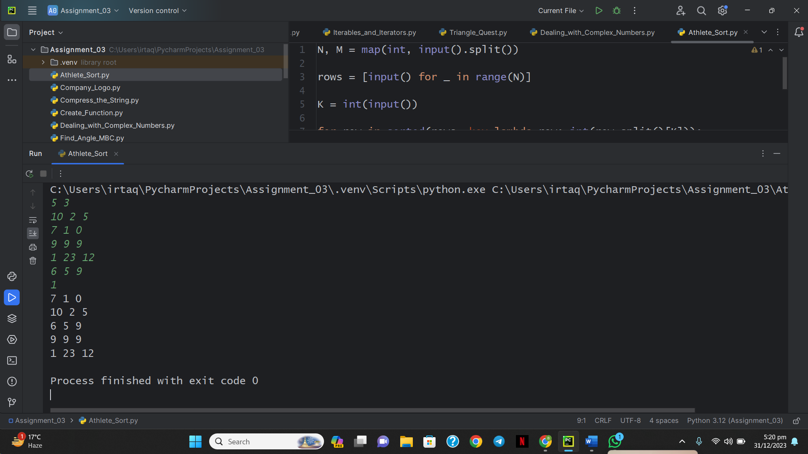

**16: ginortS**

s = input()

upper, lower, odd, even =[], [], [], []

for char in s:

    if char.isnumeric():

        if int(char) % 2==0:

            even.append(char)

        else:

            odd.append(char)

    else:

        if char.isupper():

            upper.append(char)

        else:

            lower.append(char)

print(''.join(sorted(lower))+''.join(sorted(upper))+''.join(sorted(odd))+''.join(sorted(even)))

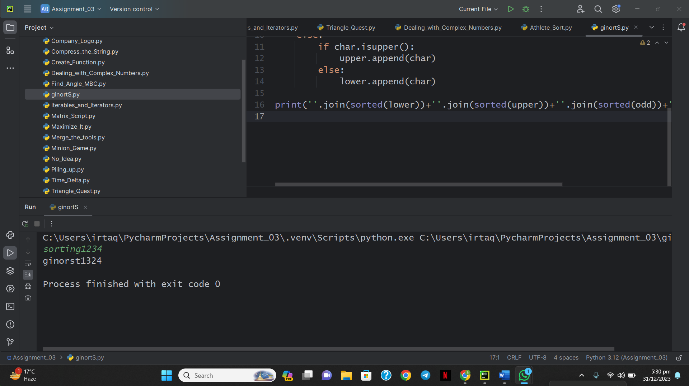

**17: Validating Email Address with a Filter**

def fun(s):

    try:

        username, url = s.split('@')

        website, extension = url.split('.')

    except ValueError:

        return False

    if username.replace('-', '').replace('_', '').isalnum() is False:

        return False

    elif website.isalnum() is False:

        return False

    elif len(extension) > 3:

        return False

    else:

        return True

def filter_mail(emails):

    return list(filter(fun, emails))

if __name__ == '__main__':

    n = int(input())

    emails = []

    for _ in range(n):

        emails.append(input())

filtered_emails = filter_mail(emails)

filtered_emails.sort()

print(filtered_emails)

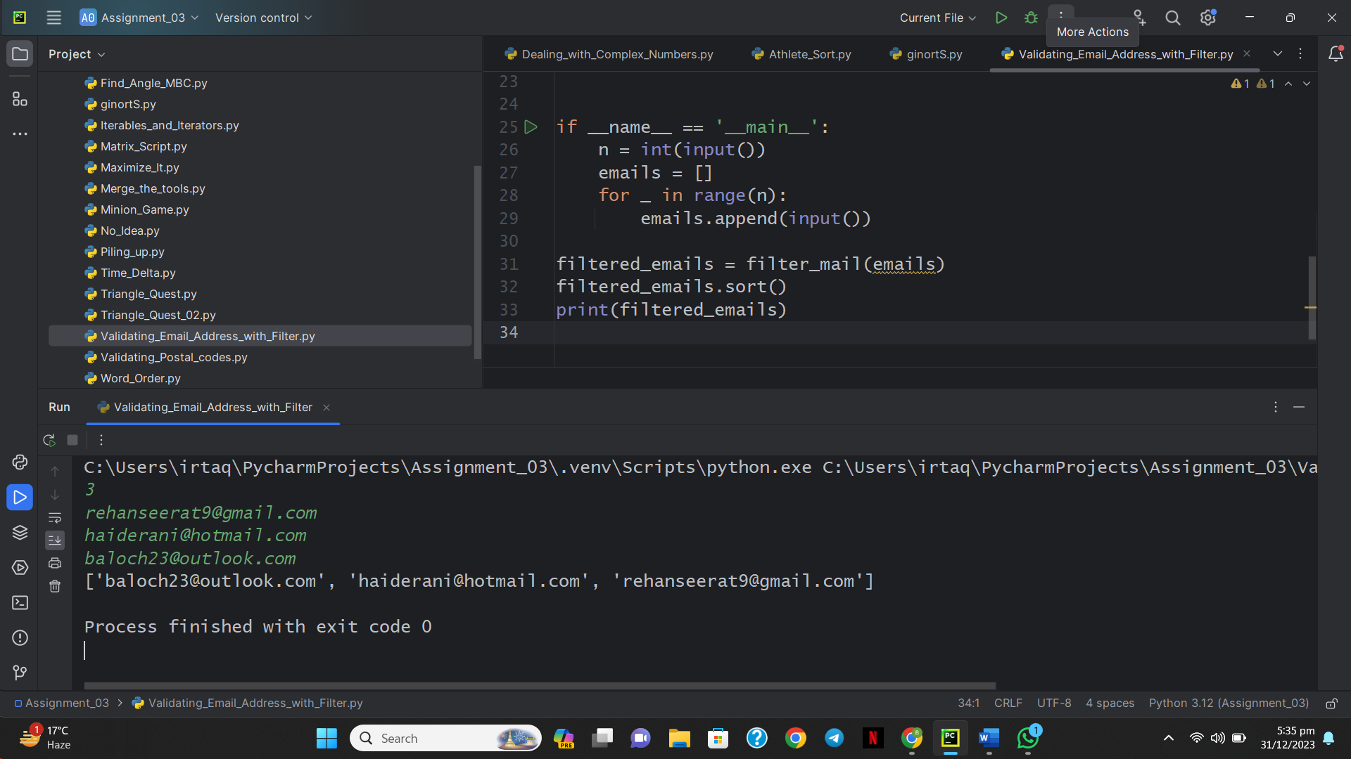

**18: Reduce Function**

rom fractions import Fraction

from functools import reduce

def product(fracs):

    t = Fraction(reduce(lambda x, y: x * y, fracs))

    return t.numerator, t.denominator

if __name__ == '__main__':

    fracs = []

    for _ in range(int(input())):

        fracs.append(Fraction(*map(int, input().split())))

    result = product(fracs)

    print(*result)

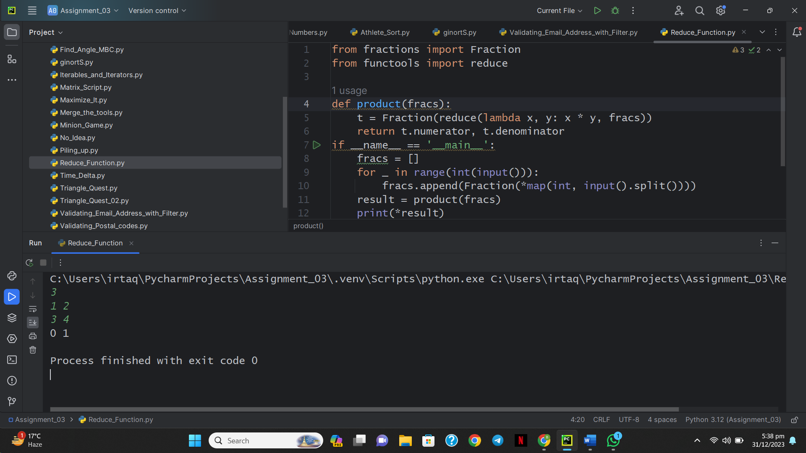

**19: Regex Substitution**

import re

def change(match):

    if match.group(1) == '&&':

        return 'and'

    else:

        return 'or'

for _ in range(int(input())):

    print(re.sub(r"(?<= )(\|\||&&)(?= )", change, input()))

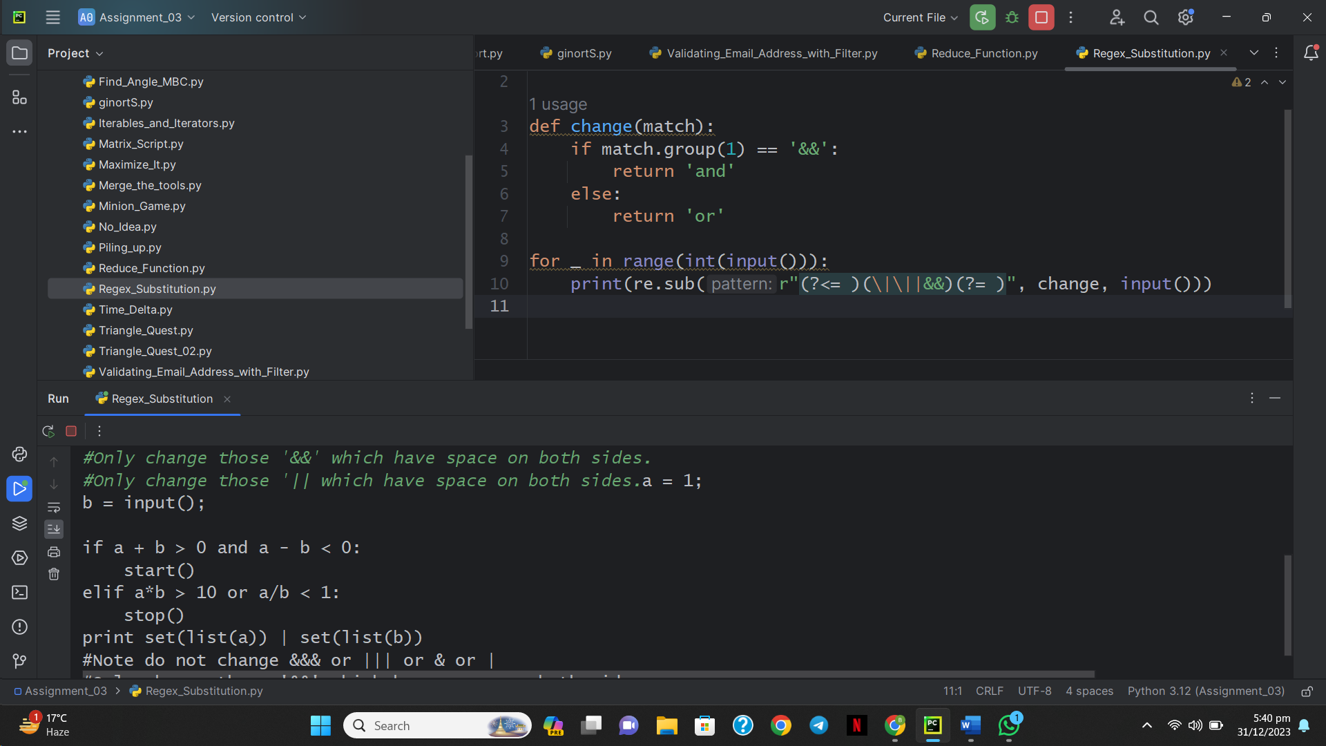

**20: Validating Credit Card Numbers**

import re

pattern = re.compile(

    r'^'

    r'(?!.*(\d)(-?\1){3})'

    r'[456]\d{3}'

    r'(?:-?\d{4}){3}'

    r'$')

for _ in range(int(input().strip())):

    print('Valid' if pattern.search(input().strip()) else 'Invalid')

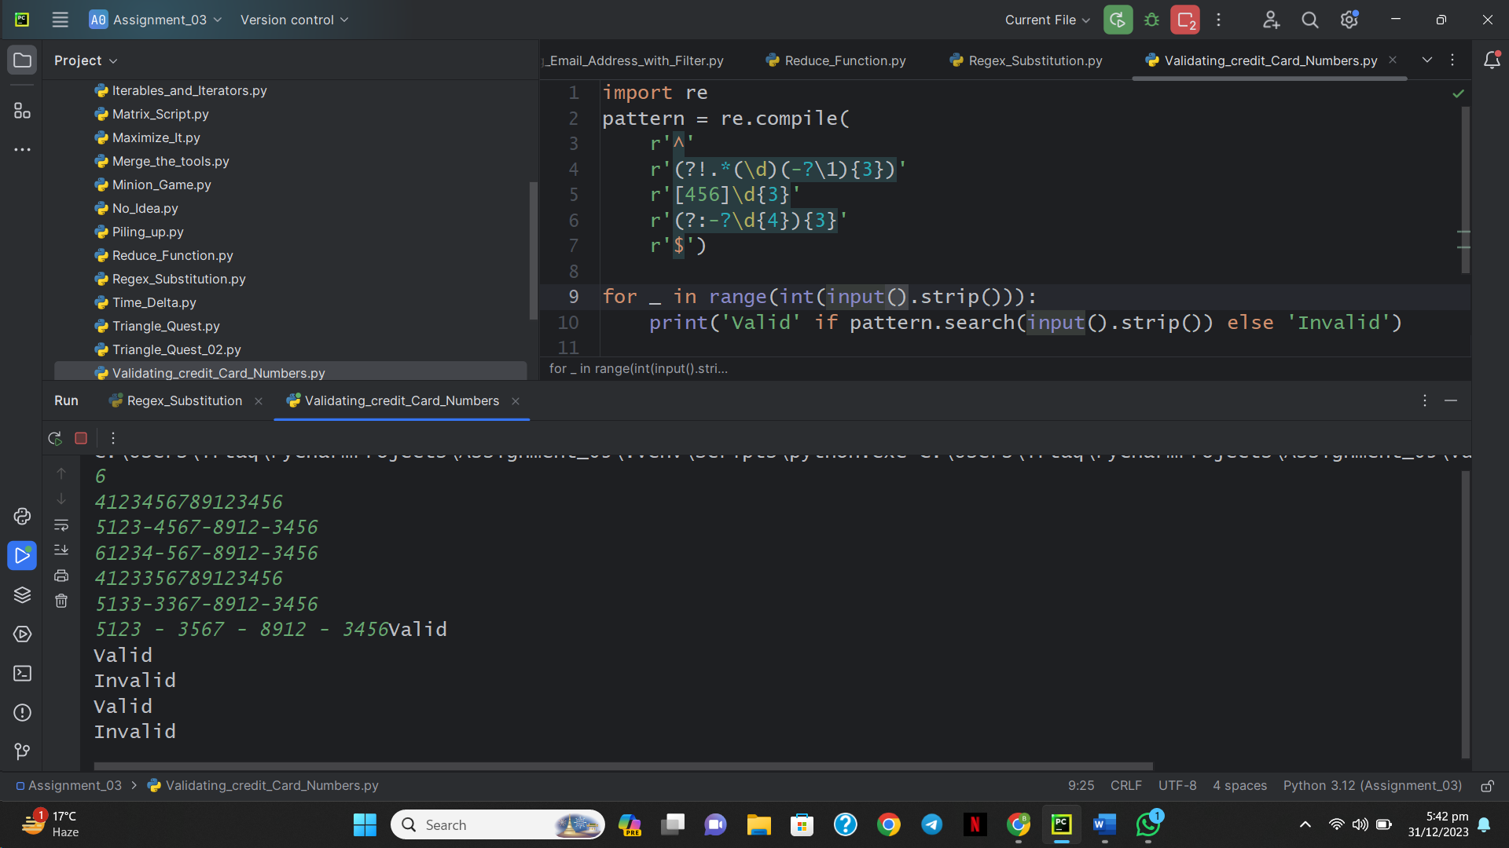

**21: Words Score**

def is_vowel(letter):

    return letter in ['a', 'e', 'i', 'o', 'u', 'y']

def score_words(words):

    score = 0

    for word in words:

        num_vowels = 0

        for letter in word:

            if is_vowel(letter):

                num_vowels += 1

        if num_vowels % 2 == 0:

            score += 2

        else:

            score += 1

    return score

n= int(input())

words = input().split()

print(score_words(words))

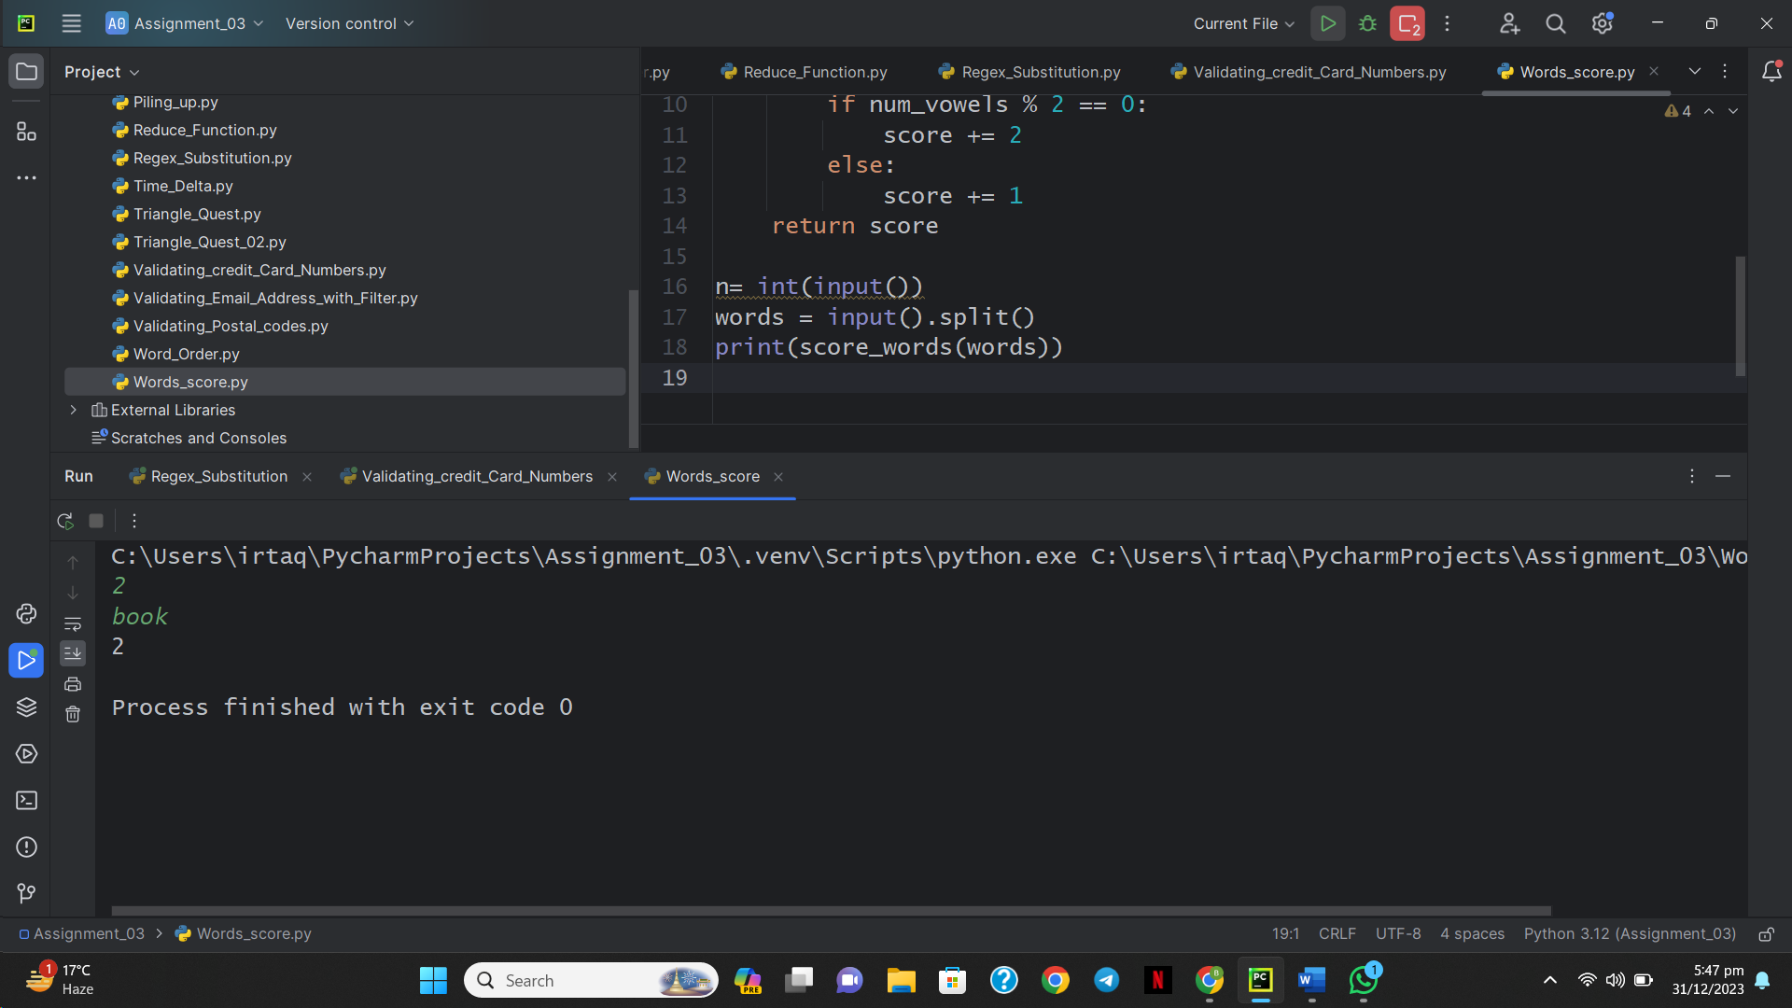

**22: Default Arguments**

class EvenStream(object):

    def __init__(self):

        self.current = 0

    def get_next(self):

        to_return = self.current

        self.current += 2

        return to_return

class OddStream(object):

    def __init__(self):

        self.current = 1

    def get_next(self):

        to_return = self.current

        self.current += 2

        return to_return

def print_from_stream(n, stream=None):

    if stream is None:

        stream = EvenStream()

    for _ in range(n):

        print(stream.get_next())

queries = int(input())

for _ in range(queries):

    stream_name, n = input().split()

    n = int(n)

    if stream_name == "even":

        print_from_stream(n)

    else:

        print_from_stream(n, OddStream())

